**3GPP TSG-RAN WG4 Meeting** **#114-bis R4-2503268**

**Wuhan, China, 7th Apr 2025 – 11th Apr 2025**

**Agenda item:** 7.16.2

**Source:** MediaTek Inc.

**Title:** Simulation results of Spatial Channel Modelling

**Document for:** Discussion

# Introduction

In RAN4#114, RAN4 agreed set of alignment simulations for Spatial Channel Modelling [1]. In this contribution, we provide our simulation results for Spatial Channel Modelling.

# Simulation results

## 2.1 Simulation parameters

In this Chapter, we provide our simulation setup and results for Spatial Channel Modelling. In RAN4#113, RAN4 agreed that general simulation configuration can follow existing 38.101-4 8RX TDD requirement configuration specified in Chapter 5.2.4.2.1 [2]. Common parameters are listed in Table 1. We have assumed 0% TxEVM and LMMSE MIMO demodulation.

Table 1: Common test parameters of 4RX and 8RX tests (Table 5.2.4.2.1-2 in [2])

|  |  |  |  |
| --- | --- | --- | --- |
| **Parameter** | | **Unit** | **Value** |
| Duplex mode | |  | TDD |
| Active DL BWP index | |  | 1 |
| PDSCH configuration | Mapping type |  | Type A |
| k0 |  | 0 |
| Starting symbol (S) |  | 2 |
| Length (L) |  | 12 |
| PDSCH aggregation factor |  | 1 |
| PRB bundling type |  | Static |
| PRB bundling size |  | 2 |
| Resource allocation type |  | Type 0 |
| RBG size |  | Config2 |
| VRB-to-PRB mapping type |  | Non-interleaved |
| VRB-to-PRB mapping interleaver bundle size |  | N/A |
| PDSCH DMRS configuration | DMRS Type |  | Type 1 |
| Number of additional DMRS |  | 1 |
| Maximum number of OFDM symbols for DL front loaded DMRS |  | 1 for rank <= 4  2 for rank > 4 |
| Codebook configuration | CodebookType |  | typeI-SinglePanel |
| CodebookMode |  | 1 |
| (CodebookConfig-N1,CodebookConfig-N2) |  | (2,1) for 4Tx  (4,1) for 8Tx |
| (CodebookConfig-O1,CodebookConfig-O2) |  | (4,1) |
| CSI-RS for tracking | First OFDM symbol in the PRB used for CSI-RS |  | l0 = 5 for CSI-RS resource 1 and 3  l0 = 9 for CSI-RS resource 2 and 4 |
| Number of HARQ Processes | |  | 8 |
| The number of slots between PDSCH and corresponding HARQ-ACK information | |  | Specific to each TDD UL-DL pattern and as defined in Annex A.1.2 |

Test specific MCS with common system bandwidth, subcarrier spacing, and TDD UL-DL pattern are listed in Table 2. Note that demodulation tests use only Ranks 4 and 8, whereas PMI tests use only Ranks 2 and 4. Also note that PDSCH data is allocated only in full slots, i.e. not in special slots in our simulations.

Table 2: Test parameters of 4RX and 8RX demodulation and PMI tests

|  |  |  |  |  |
| --- | --- | --- | --- | --- |
| **Test** | **Bandwidth (MHz) / Subcarrier spacing (kHz)** | **Modulation format and code rate** | **TDD UL-DL pattern** | **Test type** |
| Rank 2 | 40 / 30 | 16QAM, 0.48 (MCS13) | FR1.30-1 | PMI |
| Rank 4 | 40 / 30 | 16QAM, 0.48 (MCS13) | FR1.30-1 | Demodulation, PMI |
| Rank 8 | 40 / 30 | 16QAM, 0.48 (MCS13) | FR1.30-1 | Demodulation |

Our CDL channel model implementation strictly follows TR38.827 (A1) including ray splitting. We have also simulated CDL model options A2 and A3. However, the channel cluster parameter tables were later changed, which renders our simulation results in A2 and A3 obsolete. We have therefore omitted those results from this document.

CDL channel parameters are listed in Table 3 for general parameters and in Table 4 for transmit beamforming related parameters. The concept of antenna array virtualization (AAV) via TX beamforming is illustrated in Figure 1. For CDL channel we have simulated 2 different AAV options. These options were listed in previous WF [1].

Table 3: CDL channel parameters

|  |  |
| --- | --- |
| Carrier frequency | 3.5 GHz |
| UE speed | 3 or 30 km/h |
| UE travelling direction (*f*v, *q*v) | (65°, 90o) |
| Channel profile | 827 UMa CDL-C (A1) |
| Antenna array virtualization for 4RX | * No AAV (1, 2, 2, 1, 1) (Direct passthrough) * AAV 1Y (8, 2, 2, 8, 1) (Fixed subarray size) |
| Antenna array virtualization for 8RX | * No AAV (1, 4, 2, 1, 1) (Direct passthrough) * AAV 1Y (8, 4, 2, 8, 1) (Fixed subarray size) |
| Subarray virtualizer for Fixed subarray size | * Broadside, i.e. all ones |
| BS (α, β, γ) | (0**°**, 10**°**, 0**°**) |
| BS polarization slant | (45°, -45o) |
| UE (α, β, γ) | (180**°**, 0**°**, 0**°**) |
| UE polarization slant | (0°, 90o) |
| BS antenna radiation pattern | As defined in TR38.901 Table 7.3-1 |
| UE antenna radiation pattern | Omnidirectional |

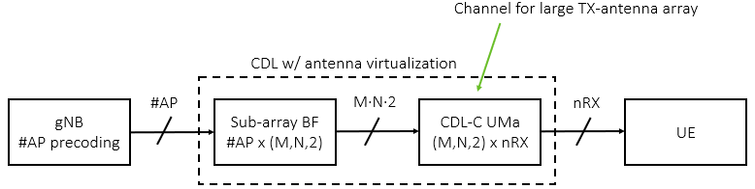

**Figure 1: Antenna array virtualization (AAV) concept**

## 2.2 PDSCH demodulation testing in CDL-C

In Figure 2 we show PDSCH demodulation performance of Rank 4 MCS13 using random precoding.

In Figure 3 we show PDSCH demodulation performance of Rank 8 MCS13 with AAV 1Y using both random and fixed precoding.

In Figure 4 we show PDSCH demodulation performance of Rank 8 MCS13 with No AAV using both random and fixed precoding.

|  |
| --- |
|  |

**Figure 2: 4TX-4RX Rank 4 with random precoding**

|  |  |
| --- | --- |
|  |  |

**Figure 3: AAV 1Y with 8TX-8RX Rank 8 (left: 3 km/h, right: 30 km/h)**

|  |  |
| --- | --- |
|  |  |

**Figure 4: No AAV with 8TX-8RX Rank 8 (left: 3 km/h, right: 30 km/h)**

In Table 4 we list the required SNR in each test to achieve 70% relative throughput in 4RX TDD Rank 4 using random precoding.

In Table 5 we list the required SNR in each test to achieve 70% relative throughput in 8RX TDD Rank 8 using both random and the best fixed precoder.

Table 4: SNR [dB] at 70% tput for 4TX-4RX Rank 4

|  |  |
| --- | --- |
| CDL-C-UMa A1 | Rank 4 |
| AAV 1Y (3 km/h) / random precoding | 16.6 |
| AAV 1Y (30 km/h) / random precoding | 17.7 |
| No AAV (3 km/h) / random precoding | 16.6 |
| No AAV (30 km/h) / random precoding | 17.4 |

Table 5: SNR [dB] at 70% tput for 8TX-8RX Rank 8

|  |  |  |  |
| --- | --- | --- | --- |
| CDL-C-UMa A1 | Rank 8 | | |
| CW0 | CW1 | Total |
| AAV 1Y (3 km/h) / random precoding | 19.2 | N/A | 21.4 |
| AAV 1Y (3 km/h) / fixed precoder [4, 0, 0] | 19.3 | 23.2 | 21.0 |
| AAV 1Y (30 km/h) / random precoding | 19.6 | N/A | 22.0 |
| AAV 1Y (30 km/h) / fixed precoder [4, 0, 0] | 20.1 | 24.0 | 21.7 |
| No AAV (3 km/h) / random precoding | 18.5 | 28.6 | 20.7 |
| No AAV (3 km/h) / fixed precoder [4, 0, 0] | 19.1 | 21.3 | 20.1 |
| No AAV (30 km/h) / random precoding | 19.2 | 29.3 | 21.5 |
| No AAV (30 km/h) / fixed precoder [4, 0, 0] | 20.3 | 22.1 | 21.1 |

## 2.3 Follow-PMI testing in CDL-C

In Figures 5-8 we show performance of different PMI reporting options (Type1 WB-PMI, eType2 SB-PMI, and random Type1 with both WB and SB-PMI) with MCS13. Figures 5-6 depict results for Rank 2 and Figures 7-8 for Rank 4. PMI feedback delay is 6.5 ms. For eType2, subband size 8 PRBs and *paramCombination-r16* 6 are used.

|  |  |
| --- | --- |
|  |  |

**Figure 5: AAV 1Y 8TX-4RX Rank 2 PMI reporting in CDL-C-UMa (left: 3 km/h, right: 30 km/h)**

|  |  |
| --- | --- |
|  |  |

**Figure 6:** **No AAV 8TX-4RX Rank 2 PMI reporting in CDL-C-UMa (left: 3 km/h, right: 30 km/h)**

|  |  |
| --- | --- |
|  |  |

**Figure 7: AAV 1Y 8TX-4RX Rank 4 PMI reporting in CDL-C-UMa (left: 3 km/h, right: 30 km/h)**

|  |  |
| --- | --- |
|  |  |

**Figure 8: No AAV 8TX-4RX Rank 4 PMI reporting in CDL-C-UMa (left: 3 km/h, right: 30 km/h)**

In Table 6 we list the required SNR to achieve 90% relative throughput in PMI tests with different PMI reporting options, ranks, AAV options, and UE speeds.

In Table 7 we list gammas (throughput ratio between follow and random PMI) for both Type1 WB-PMI and eType2 SB-PMI.

Note that for random Type1 SB-PMI, index i1 is drawn in wideband mode while i2 is drawn per subband. For gamma calculations, the reference for Type1 WB-PMI reporting is Type1 random WB-PMI. The reference for eType2 SB-PMI reporting is Type1 random SB-PMI.

Table 6: SNR [dB] at 90% relative tput of 8TX-4RX PMI reporting

|  |  |  |  |  |  |
| --- | --- | --- | --- | --- | --- |
| CDL-C-UMa A1 | | Type1 follow WB-PMI | Type1 random WB-PMI | Type1 random SB-PMI | eType2 follow SB-PMI |
| Rank 2 | AAV 1Y (3 km/h) | 3.6 | 14.6 | 14.6 | 3.3 |
| AAV 1Y (30 km/h) | 4.1 | 14.6 | 14.9 | 4.9 |
| No AAV (3 km/h) | 3.7 | 14.2 | 14.2 | 3.4 |
| No AAV (30 km/h) | 4.5 | 14.2 | 14.5 | 5.3 |
| Rank 4 | AAV 1Y (3 km/h) | 12.9 | N/A | N/A | 14.1 |
| AAV 1Y (30 km/h) | 13.7 | N/A | N/A | 15.3 |
| No AAV (3 km/h) | 12.8 | N/A | N/A | 14.0 |
| No AAV (30 km/h) | 13.8 | N/A | N/A | 15.6 |

Table 7: Gammas of 8TX-4RX PMI reporting

|  |  |  |  |
| --- | --- | --- | --- |
| CDL-C-UMa A1 | | Type1  WB-PMI | eType2  SB-PMI |
| Rank 2 | AAV 1Y (3 km/h) | 2.41 | 2.51 |
| AAV 1Y (30 km/h) | 2.24 | 2.06 |
| No AAV (3 km/h) | 2.34 | 2.47 |
| No AAV (30 km/h) | 2.11 | 1.96 |
| Rank 4 | AAV 1Y (3 km/h) | 1.81 | 1.68 |
| AAV 1Y (30 km/h) | 1.76 | 1.61 |
| No AAV (3 km/h) | 1.78 | 1.65 |
| No AAV (30 km/h) | 1.70 | 1.54 |

## 2.4 SNR normalization factor in CDL-C

Let normalized AAV beamformer vector of length *Ms∙Ns* (i.e. sub-array size) for one antenna port be

Here, amplitude normalization is separated into two factors

* : split transmit power of each AP evenly over *Ms∙Ns* transmit antenna elements
* : normalize with measured transmit beamforming (power) gain *G*BF

Measured SNR normalization factors, in dB and linear values, are listed in Tables 8-10.

Table 8: SNR normalization factors of 4TX-4RX

|  |  |  |
| --- | --- | --- |
| CDL-C-UMa | *G*BF | |
| dB | Linear |
| No AAV (1,2,2,1,1) | -0.159 | 0.964 |
| AAV 1Y (8,2,2,8,1) | 7.885 | 6.144 |

Table 9: SNR normalization factors of 8TX-8RX

|  |  |  |
| --- | --- | --- |
| CDL-C-UMa | *G*BF | |
| dB | Linear |
| No AAV (1,4,2,1,1) | -0.162 | 0.963 |
| AAV 1Y (8,4,2,8,1) | 7.885 | 6.144 |

Table 10: SNR normalization factors of 8TX-4RX

|  |  |  |
| --- | --- | --- |
| CDL-C-UMa | *G*BF | |
| dB | Linear |
| No AAV (1,4,2,1,1) | -0.160 | 0.964 |
| AAV 1Y (8,4,2,8,1) | 7.884 | 6.144 |

## 2.5 Eigenmode power distribution of CDL-C

To enable further channel model alignment, we measured the average eigenmode powers of the MIMO channel for the different AAV options. We sampled the MIMO channel frequency response over frequency and time domains over the simulation, and for each *Nrx×Ntx* MIMO channel sample, singular values (SVD) were calculated and sorted from largest to smallest. Squared singular values were then averaged over the simulation and converted to relative dB values shown in Tables 11, 12, and 13.

Table 11: Average relative eigenmode powers [dB] of 4TX-4RX

|  |  |  |  |  |
| --- | --- | --- | --- | --- |
| CDL-C-UMa | 1 | 2 | 3 | 4 |
| No AAV (1,2,2,1,1) | 0.00 | -4.58 | -12.22 | -19.55 |
| AAV 1Y (8,2,2,8,1) | 0.00 | -4.62 | -12.95 | -20.21 |

Table 12: Average relative eigenmode powers [dB] of 8TX-8RX

|  |  |  |  |  |  |  |  |  |
| --- | --- | --- | --- | --- | --- | --- | --- | --- |
| CDL-C-UMa | 1 | 2 | 3 | 4 | 5 | 6 | 7 | 8 |
| No AAV (1,4,2,1,1) | 0.00 | -3.11 | -6.52 | -10.16 | -16.43 | -20.44 | -25.57 | -33.80 |
| AAV 1Y (8,4,2,8,1) | 0.00 | -3.15 | -6.71 | -10.52 | -17.97 | -22.33 | -27.57 | -35.49 |

Table 13: Average relative eigenmode powers [dB] of 8TX-4RX

|  |  |  |  |  |
| --- | --- | --- | --- | --- |
| CDL-C-UMa | 1 | 2 | 3 | 4 |
| No AAV (1,2,2,1,1) | 0.00 | -3.78 | -8.22 | -13.80 |
| AAV 1Y (8,2,2,8,1) / Broadside | 0.00 | -3.85 | -8.50 | -14.35 |

## 2.6 PDSCH demod testing in multi-cluster TDL channels (cluster model 1)

In this section, we show simulation results of the multi-cluster TDL approach as described in the corresponding TP to TR38.753 [3] with a cluster power parameter sweep. All simulations employ LMMSE MIMO demodulation.

In Figure 9, simulation results with random precoding are shown. Figure 9 (Left) shows results for 4TX-4RX-4L in a 2-cluster TDL-C channel, for which the channel parameters are detailed in Table 13. Figure 9 (Right) shows results for 8TX-8RX-8L in a 4-cluster TDL-A channel, for which the channel parameters are listed in Table 14. Here, variable levels of cluster power imbalance *x* are experimented by setting [p1, p2] = [0, -*x*] dB for the 2-cluster channel, and [p1, p2, p3, p4] = [0, -*x*, 0, -*x*] dB for the 4-cluster channel. As can be seen, the higher the imbalance, the higher the SNR requirement to achieve any desired tput level. As can also be seen form Figure 9 (Right) for this specific channel setup with 8 layers, random precoding effectively equalizes the CW-specific performances to the same level.

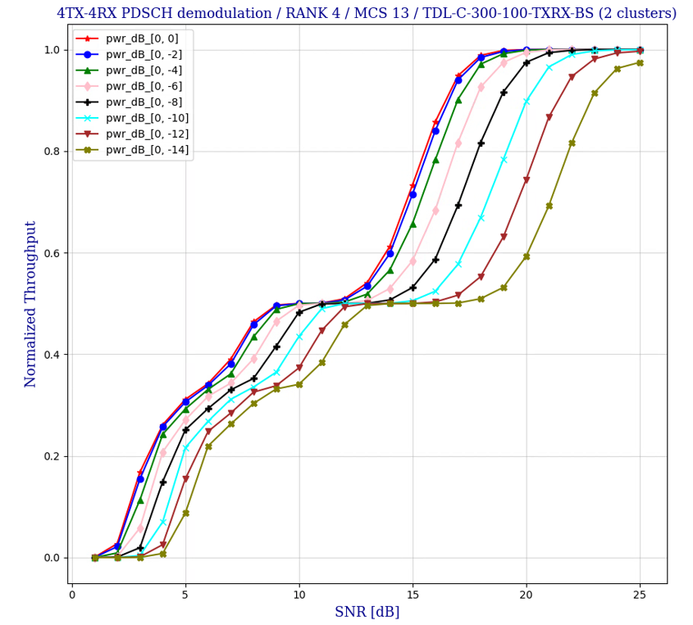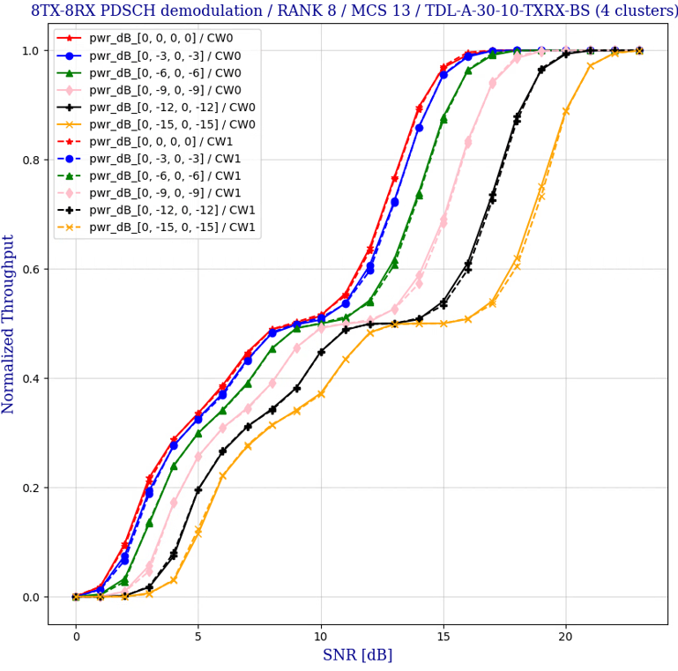

**Figure 9: Random precoder in multi-cluster TDL channels, 4TX-4RX-4L with TDL-C, 8T-8RX-8L with TDL-A.**

In Figure 10, simulation results for 8TX-8RX-8L PDSCH demodulation in a 4-cluster TDL-C channel for fixed Type1 precoder (i11 = i12 = i2 = 0) are given. The channel parameters are listed in Table 14. Here, the cluster phases are chosen so that the first two clusters correspond to CW0 precoder beams and the last two clusters correspond to CW1 precoder beams. As can be seen in Figure 10 (Left), assigning even cluster powers between CWs results in equal tput performance for both CWs. However, introducing an imbalance between the two beams of each CW results in an overall tput degradation. On the other hand, as can be seen in Figure 10 (Right), assigning imbalanced cluster powers between the CWs results in a clear tput performance deviation between the CWs.

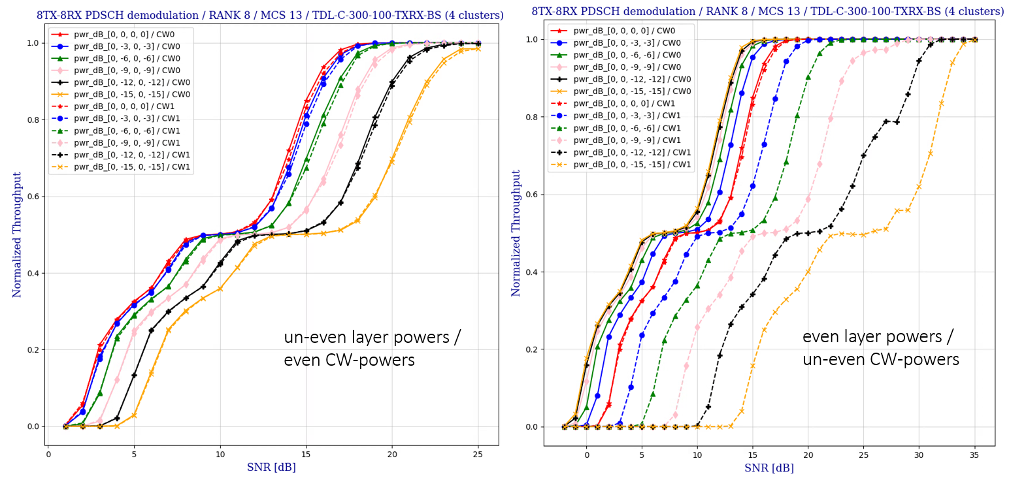

**Figure 10: 8TX-8RX-8L fixed precoder tput in 4-cluster TDL-C channel.**

Table 13: 2-cluster TDL channel parameters

|  |  |
| --- | --- |
| Array dimensions: , , , | 1, , 1 (1-dim antenna arrays) |
| Cluster powers: *p*1, *p*2 | Variable |
| Cluster TX steering: | 0, π |
| Cluster RX steering: | 0, π |
| TDL channel model per cluster | TDL-C-300 / 100 Hz Doppler / X-pol high correlation |

Table 14: 4-cluster TDL channel parameters

|  |  |
| --- | --- |
| Array dimensions:, , , | 1, , 1 (1-dim antenna arrays) |
| Cluster powers: *p*1, *p*2, *p*3, *p*4 | Variable |
| Cluster TX steering: , | 0, -π/2, -π, -3π/2 |
| Cluster RX steering: , | 0, -π/2, -π, -3π/2 |
| TDL channel model per cluster | TDL-A-30 / 10 Hz Doppler / X-pol high correlation  TDL-C-300 / 100 Hz Doppler / X-pol high correlation |

## 2.7 PDSCH demod testing in multi-cluster TDL channels (cluster model 2)

In this section, we show alignment simulation results of the TDL cluster model 2 approach as described in the corresponding TP to TR38.753 [3]. All simulations employ LMMSE MIMO demodulation.

The parameters for 2-cluster, 3-cluster, and 6-cluster channel models are listed in Table 15, Table 16, and Table 17 respectively.

Table 15: Enhanced TDLC-300-100Hz / X-pol High correlation channel with 2 clusters

|  |  |  |  |
| --- | --- | --- | --- |
| Tap | Delay (ns) | Power (dB) | Beam Steering |
| 1 | 0 | -6.9 |  |
| 2 | 65 | 0 |
| 3 | 70 | -7.7 |
| 4 | 190 | -2.5 |
| 5 | 195 | -2.4 |  |
| 6 | 200 | -9.9 |
| 7 | 240 | -8.0 |
| 8 | 325 | -6.6 |
| 9 | 520 | -7.1 |
| 10 | 1045 | -13.0 |
| 11 | 1510 | -14.2 |
| 12 | 2595 | -16.0 |

Table 16: Enhanced TDLC-300-100Hz / X-pol High correlation channel with 3 clusters

|  |  |  |  |
| --- | --- | --- | --- |
| Tap | Delay (ns) | Power (dB) | Beam steering |
| 1 | 0 | -6.9 |  |
| 2 | 65 | 0 |
| 3 | 70 | -7.7 |
| 4 | 190 | -2.5 |  |
| 5 | 195 | -2.4 |
| 6 | 200 | -9.9 |  |
| 7 | 240 | -8.0 |
| 8 | 325 | -6.6 |
| 9 | 520 | -7.1 |
| 10 | 1045 | -13.0 |
| 11 | 1510 | -14.2 |
| 12 | 2595 | -16.0 |

Table 17: Enhanced TDLC-300-100Hz / X-pol High correlation channel with 6 clusters

|  |  |  |  |
| --- | --- | --- | --- |
| Tap | Delay (ns) | Power | Beam steering |
| 1 | 0 | -6.9 |  |
| 2 | 65 | 0 |  |
| 3 | 70 | -7.7 |
| 4 | 190 | -2.5 |  |
| 5 | 195 | -2.4 |  |
| 6 | 200 | -9.9 |
| 7 | 240 | -8.0 |  |
| 8 | 325 | -6.6 |
| 9 | 520 | -7.1 |  |
| 10 | 1045 | -13.0 |
| 11 | 1510 | -14.2 |
| 12 | 2595 | -16.0 |

The results are shown in Figure 11 for both 4TX-4RX-4L and 8TX-8RX-8L with random precoding. In addition to the multi-cluster channels, performance in legacy TDL-C channel with XP-high and low correlation are shown as well.

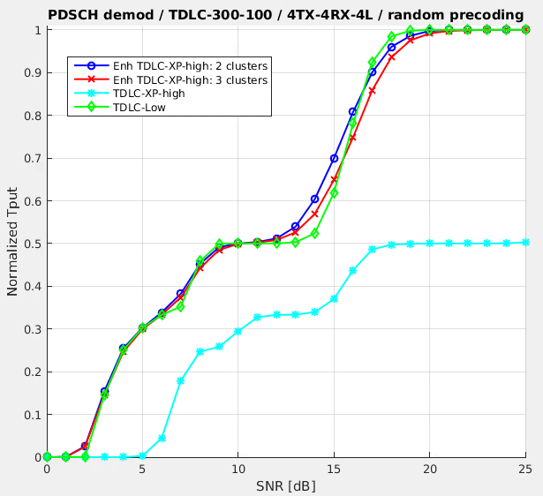 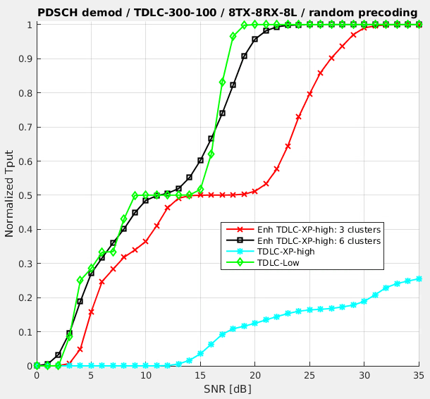

**Figure 11: Random precoder in multi-cluster TDL-C channels (left: 4TX-4RX-4L, right: 8TX-8RX-8L)**

# Conclusion

In this paper we provided our simulation setup and results for Spatial Channel Modelling.

# Reference

1. R4-2502378, “Way Forward for [114][322] NR_SCM”, Nokia
2. 3GPP TS 38.101-4 V18.6.0 (2024-12), User Equipment (UE) radio transmission and reception, Part 4: Performance requirements
3. R4-2503269, “TP to TR38.753: TDL approaches and related Annex”, MediaTek